Paper Title

Full Name Surname¹, Full Name Surname², Full Name Surname³
¹Department, Faculty, University, City, Country
email@domain.com | ORCID: 0000-0000-0000-0000
²Department, Faculty, University, City, Country
email@domain.com | ORCID: 0000-0000-0000-0000
³Department, Faculty, University, City, Country
email@domain.com | ORCID: 0000-0000-0000-0000

Use full given name(s) and surname(s) for all authors. Match each author to the correct affiliation with superscript numbers, identify one corresponding author, and include ORCID information when available.

ABSTRACT
The abstract should briefly state the research problem or context, objective, method, most important quantitative or qualitative findings, and principal conclusion in a single concise paragraph. References, tables, figures, and undefined abbreviations should not be included.
Keywords: keyword 1, keyword 2, keyword 3, keyword 4, keyword 5
Provide approximately five specific keywords separated by commas. Keywords should improve discoverability and should avoid unnecessary repetition of the paper title.
The full paper must not exceed 6 pages, including references, figures, and tables.

1. INTRODUCTION
The introduction should explain the background and significance of the topic, define the research problem, summarize the most relevant prior work, identify the research gap, and conclude with the objective and main contribution of the study. Abbreviations should be defined at first use, and SI units should be used consistently.
In-text citation example: Recent studies have reported similar improvements in engineering applications [1]. Related findings were also presented in [2, 3], while broader comparisons are available in [4-6]. Number references in the order of first appearance and use square brackets consistently.

1.1. Subsection Title
Subsections may be used when they improve readability. Subsection titles should be brief and descriptive, and each subsection should contain sufficient content to justify its use.

Bulleted list example:
- Use bullets for items of equal importance.
- Keep list items concise and grammatically parallel.
- Use Word list formatting rather than manually typed symbols or tabs.

Numbered list example:
- Describe the first ordered step.
- Continue with the next step in sequence.
- End with the final step or priority.

2. MATERIALS AND METHODS
This section should describe the data or materials, study design, experimental setup, algorithms or analytical procedures, software and hardware, parameter settings, and statistical methods in sufficient detail to support reproducibility. Dataset splits, sample sizes, evaluation protocols, and ethical approval should be reported when relevant.

2.1. Equations
Equations should be created with the Word Equation tool rather than inserted as images. Displayed equations should be centered and numbered consecutively, with the equation number aligned to the right. Every symbol should be defined immediately before or after the equation.

 | RMSE = √[(1/n) Σᵢ₌₁ⁿ (yᵢ − ŷᵢ)²] | (1)

where n is the number of observations, yᵢ is the observed value, and ŷᵢ is the predicted value. Refer to the equation in the text as Eq. (1).
For stable editorial formatting, spaces or tab characters should not be used to position equations or equation numbers.

3. RESULTS AND DISCUSSION
The results should be presented in a logical order and followed by an interpretation of their meaning. Findings should be compared with relevant literature, important agreements or differences should be discussed, and the implications and limitations of the study should be addressed without unnecessarily repeating values already shown in tables or figures.

3.1. Tables
Each table should be cited in the text before it appears. Place the table number and title above the table, use consistent alignment and number formatting, and explain abbreviations, symbols, and statistical markers in a table note when needed.

Table 1. Example performance results.
Method | Accuracy (%) | Macro-F1 (%)
Method A | 87.2 | 86.9
Method B | 83.5 | 82.8
Baseline | 79.1 | 78.4

Table text should remain clear and legible. When necessary, the font size may be reduced to 6 pt, but it should not be smaller than 6 pt. The main body font should not be reduced to make a table fit. Tables should remain editable rather than being inserted as screenshots.

3.2. Figures
Each figure should be cited in the text before it appears. Figures should be inserted in line with text, with the caption placed below the image. Axis labels, legends, symbols, and annotations should remain readable at final size, and high-resolution originals should be used.

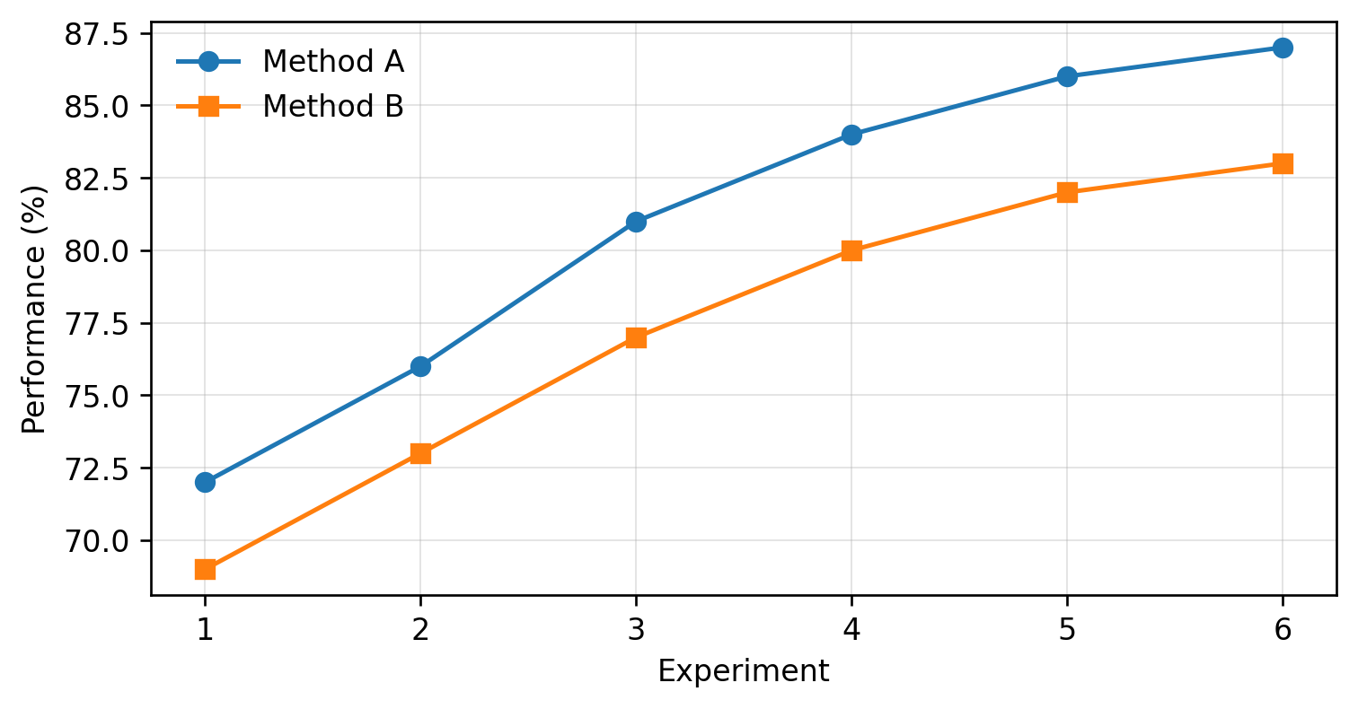
Figure 1. Example experimental performance across six runs.

Cross-reference example: “As shown in Figure 1, Method A consistently outperformed Method B.” Use Table 1, Figure 1, and Eq. (1) consistently when referring to tables, figures, and equations.

4. CONCLUSION
The conclusion should state the main findings and contribution without repeating the abstract. The most important limitations, practical implications, and specific directions for future work may also be summarized. New results should not be introduced in this section.

ACKNOWLEDGMENT
Institutional, technical, financial, or other support may be acknowledged in this section. Grant or project numbers should be included when applicable.

DECLARATIONS
This section may include statements on funding, conflict of interest, ethics approval, informed consent, data availability, or author contributions when they are applicable to the study.

REFERENCES
References should be listed in the order in which they first appear in the manuscript. A consistent numbered reference format should be used, and every in-text citation should have a matching reference entry.
- A. Author and B. Author, “Article title,” Journal Title, vol. 10, no. 2, pp. 100-110, 2026.
- C. Author, Book Title, 2nd ed. City: Publisher, 2025.
- D. Author and E. Author, “Paper title,” in Proceedings of Conference Name, City, Country, 2026, pp. 20-25.
- Organization Name, “Web page title,” 2026. Accessed: Sep. 1, 2026.

